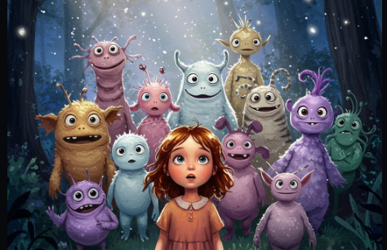

Preschool children are like little Aliens!
New to our planet & in need to be taught the ABCDs of life here !

But how do we explain to little minds,
using little words they know, the following...

- Our languages, the meaning of 100s of words ?
- Our systems to quantify and calculate ?
- What colours, shapes, seasons, verbs & words are ?
- Introduce our animals, birds, mountains & seas in all their glory?



It gets even more complex when the medium of instruction is English , a language most kids do not know ! It gets more acute when kids are from different linguistic back grounds !!

Preschool teachers must have prayed hard for :-

- A single magic means to get their attention
- With no words , given their limited vocabulary
- A means to teach them quickly & effortlessly



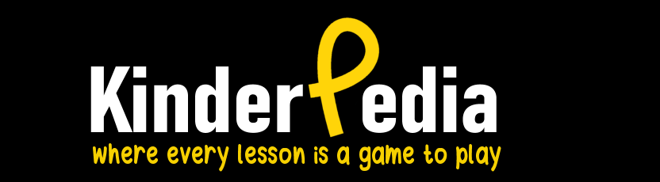

- KinderPedia uses the language of animations and curated videos, instantly getting the attention of preschool kids when delivered as touch screen Apps that most schools use these days

- It uses a GUI (Graphic User Interface) & UX (User eXperience) designed to work on the curiocity of kids without the use of words!

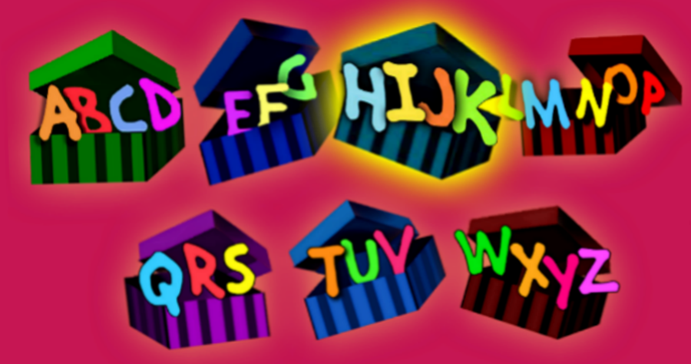

- It cuts across their linguistic differences using multmedia formats that combine audio, video, animations, graphics, bright colours to deliver the bulk of preschool content in a manner that is hard for kids to ignore



- Over 35 + apps that make teaching preschool children as easy an 123!

- Apps that teach children quickly by enablilng them to comprehend concepts behind what they learn in depth! Avoiding learning by rote.

- It can all be accessed merely by touching graphic icons – no keyboards & those strange symbols on them called letters needed!

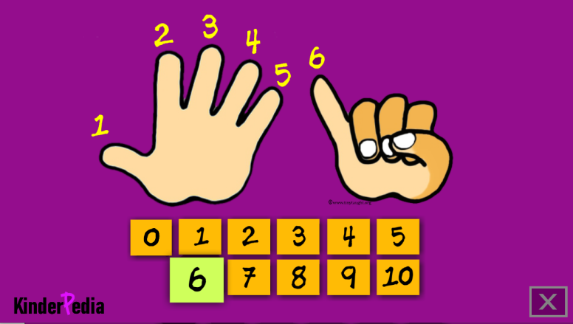

- Its a format children are familiar with well before they come to preschools, thanks to cartoon network, discovery kids, tablets & smart phones at home

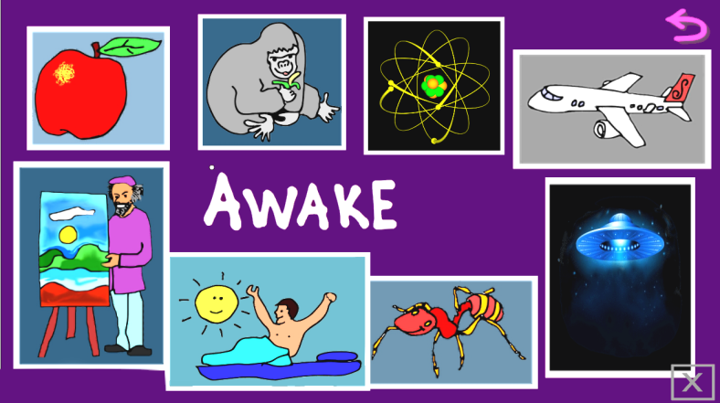

Professionals working in Multimedia harnessing AI powered tools to create animations, create and edit images, audio & videos
Makers of Apps for large Touch Interactive flat panels and Tablets meant specifically for Preschool children world wide

Fortunately for us today, we have ways to communicate clearly to these little people. In a manner they understand well, regardless of their vocabulary & linguistic backgrounds.

